Table of Contents
Maths 2
sum 2
Modulo 2
Average 2
Web Desinging 3
HTML 3
CSS 3
JavaScript 3
Sports 4
Kho-Kho 4
Cricket 4
Football 4
Java 5
Variable 5
Loops 5
Function 5

Subject

Maths

sum
Sum is the result obtained when two or more numbers are added together. It is one of the most basic and important operations in mathematics. The concept of sum is used in everyday activities such as calculating expenses, marks, profits, and totals. In programming, finding the sum of values is a common task used in calculations, data processing, and algorithms. For example, the sum of 5 and 7 is 12. Understanding how to calculate sums is essential for solving mathematical problems and performing various computational tasks.

Modulo
Modulo is a mathematical operation that finds the remainder when one number is divided by another. In programming, the modulo operator is represented by the % symbol. It is commonly used to check whether a number is even or odd, cycle through values, and perform calculations involving remainders. For example, 10 % 3 equals 1 because 10 divided by 3 leaves a remainder of 1. The modulo operation is an important tool in many algorithms and programming tasks. Understanding modulo helps programmers solve problems related to patterns, divisibility, and number manipulation efficiently.
Average
Average is a mathematical concept used to find the central value of a group of numbers. It is calculated by adding all the values together and then dividing the total by the number of values. The average helps summarize a large set of data into a single representative number. It is commonly used in education, business, sports, and statistics to compare and analyze information. For example, the average marks of students can show the overall performance of a class. Understanding averages helps in making informed decisions and interpreting data more effectively.

Web Desinging

HTML
HTML (HyperText Markup Language) is the standard markup language used to create and structure web pages. It provides the basic framework of a website by defining elements such as headings, paragraphs, images, links, tables, and forms. HTML uses tags to organize and display content in a web browser. It works together with CSS and JavaScript to create visually appealing and interactive websites. HTML is easy to learn and serves as the foundation of web development. Without HTML, it would not be possible to build and display content on the World Wide Web.

CSS
CSS (Cascading Style Sheets) is a styling language used to design and format web pages. It works together with HTML to control the appearance of elements such as colors, fonts, spacing, layouts, and animations. CSS helps make websites visually attractive and user-friendly by separating design from content. It allows developers to create responsive designs that adapt to different screen sizes and devices. With CSS, a single style sheet can be applied to multiple web pages, making website maintenance easier and more efficient. CSS is an essential technology for modern web development and plays a key role in creating professional-looking websites.

JavaScript
JavaScript is a popular programming language used to make websites interactive and dynamic. It allows developers to add features such as animations, form validation, sliders, and real-time updates to web pages. JavaScript works alongside HTML and CSS to create modern and responsive websites. It can be used for both front-end and back-end development with technologies like Node.js. JavaScript is supported by all major web browsers, making it one of the most widely used programming languages in the world. Learning JavaScript is essential for anyone interested in web development and building interactive web applications.

Sports

Kho-Kho
Kho-Kho is a traditional Indian sport that is known for its speed, agility, and teamwork. It is played between two teams, where one team chases and the other team tries to avoid being tagged. The game requires quick reflexes, strategic thinking, and excellent physical fitness. Players must work together and make fast decisions to help their team win. Kho-Kho is popular in schools and sports competitions across India because it is both exciting and easy to play. This sport helps improve stamina, coordination, and sportsmanship among players.

Cricket
Cricket is one of the most popular sports in the world, especially in countries like India, Australia, and England. It is played between two teams of eleven players each on a large circular field with a pitch at the center. The main objective of the game is to score more runs than the opposing team while batting and to dismiss the opposing batsmen while bowling. Cricket requires a combination of skill, strategy, teamwork, and concentration. Major tournaments such as the Cricket World Cup attract millions of fans from around the globe. The sport promotes discipline, sportsmanship, and physical fitness while providing entertainment to people of all ages.

Football
Football is one of the most popular sports in the world and is played by millions of people. It is a team game played between two teams, with each team trying to score goals by kicking a ball into the opponent's net. The game requires skill, teamwork, speed, and strategy to achieve success. Football is governed internationally by FIFA, which organizes major tournaments such as the FIFA World Cup. The sport promotes physical fitness, discipline, and sportsmanship among players. Football is enjoyed by people of all ages and brings fans together from different countries and cultures

Java

Variable
A variable is a fundamental concept in programming that is used to store data in a computer's memory. It acts like a container that holds information which can be changed during the execution of a program. Each variable is given a unique name so that it can be easily accessed and updated when needed. Variables can store different types of data such as numbers, text, and logical values. They help programmers write flexible and efficient code by allowing data to be reused throughout a program. Without variables, managing and processing information in software development would be much more difficult.

Loops
Loops are an important programming concept used to execute a block of code repeatedly until a specific condition is met. They help reduce code duplication and make programs more efficient and easier to maintain. Common types of loops include for, while, and do-while loops, each designed for different situations. Loops are often used for tasks such as processing data, displaying output multiple times, and iterating through collections of items. By automating repetitive operations, loops save time and improve program performance. Understanding loops is essential for writing effective and scalable programs.

Function
A function is a reusable block of code that performs a specific task in a program. It helps organize code into smaller and manageable sections, making programs easier to understand and maintain. Functions can accept inputs called parameters and can return an output after processing the data. They reduce code repetition because the same function can be called multiple times whenever needed. Functions improve the efficiency and readability of a program by promoting modular programming. They are one of the most important building blocks in software development and programming.

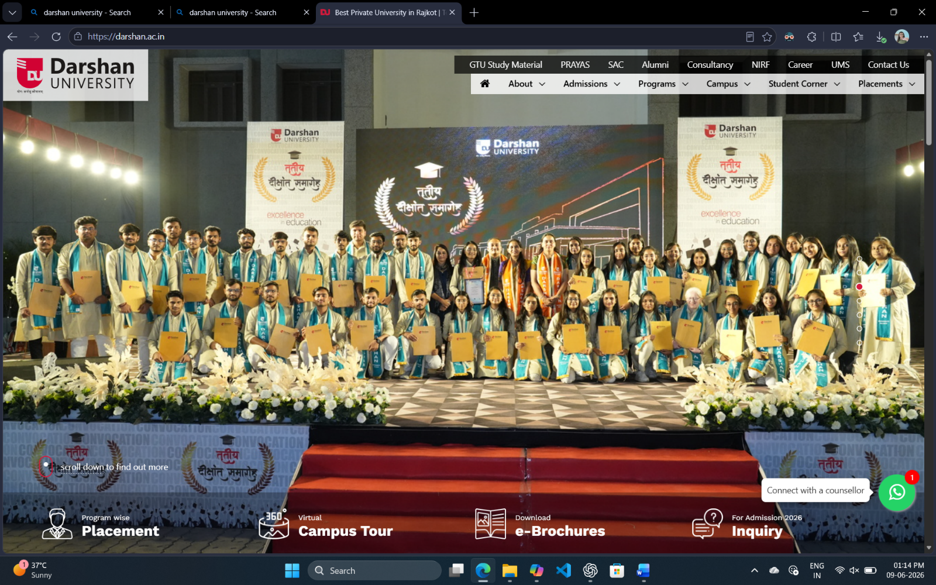

Random paragraph
Video provides a powerful way to help you prove your point. When you click Online Video, you can paste in the embed code for the video you want to add. You can also type a keyword to search online for the video that best fits your document. To make your document look professionally produced, Word provides header, footer, cover page, and text box designs that complement each other. For example, you can add a matching cover page, header, and sidebar. Click Insert and then choose the elements you want from the different galleries. Themes and styles also help keep your document coordinated.

When you click Design and choose a new Theme, the pictures, charts, and SmartArt graphics change to match your new theme. When you apply styles, your headings change to match the new theme. Save time in Word with new buttons that show up where you need them. To change the way a picture fits in your document, click it and a button for layout options appears next to it. When you work on a table, click where you want to add a row or a column, and then click the plus sign. Reading is easier, too, in the new Reading view. You can collapse parts of the document and focus on the text you want.

If you need to stop reading before you reach the end, Word remembers where you left off - even on another device. Video provides a powerful way to help you prove your point. When you click Online Video, you can paste in the embed code for the video you want to add. You can also type a keyword to search online for the video that best fits your document. To make your document look professionally produced, Word provides header, footer, cover page, and text box designs that complement each other. For example, you can add a matching cover page, header, and sidebar. Click Insert and then choose the elements you want from the different galleries.

Bullet

Subject
- HTML
- CSS
- JavaScript
- Java
- Python
- PHP

Sports
- Kho-kho
- Football
- Cricket

Subscript
H₂O
H₂SO₄

Superscript
X²
2x² + 5x

Name : Urvashi Zinzuvadiya
Roll No : 151
Class : A3

